**Assignment - 9**

**Objective** – Power BI Desktop, Cloud Service and End to End Workflow

**Use Case** – Series Insights

**Source** – Series File

**Analytics** – Ranking Series

**Report/Dashboard** – Series Insights

**Create a measure (not a calculated column) to rank each series by its viewing figures to get:**

Load Data

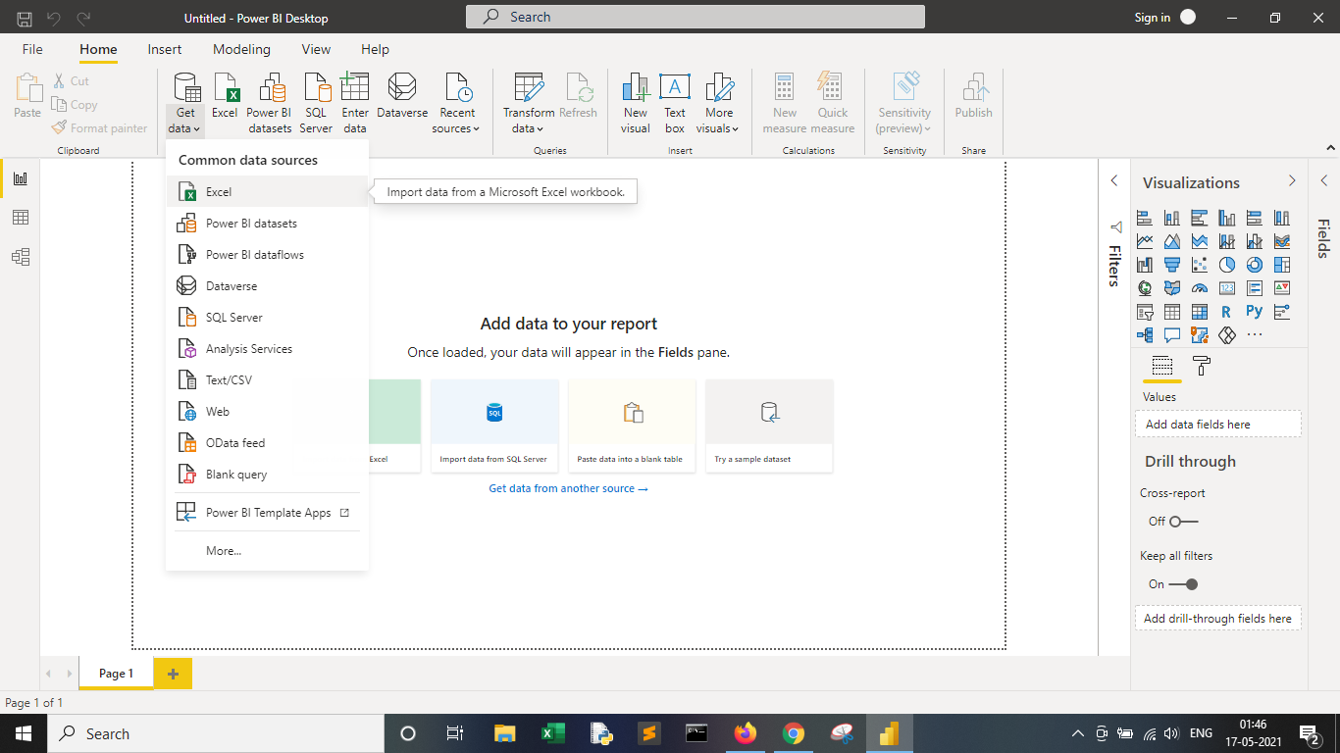

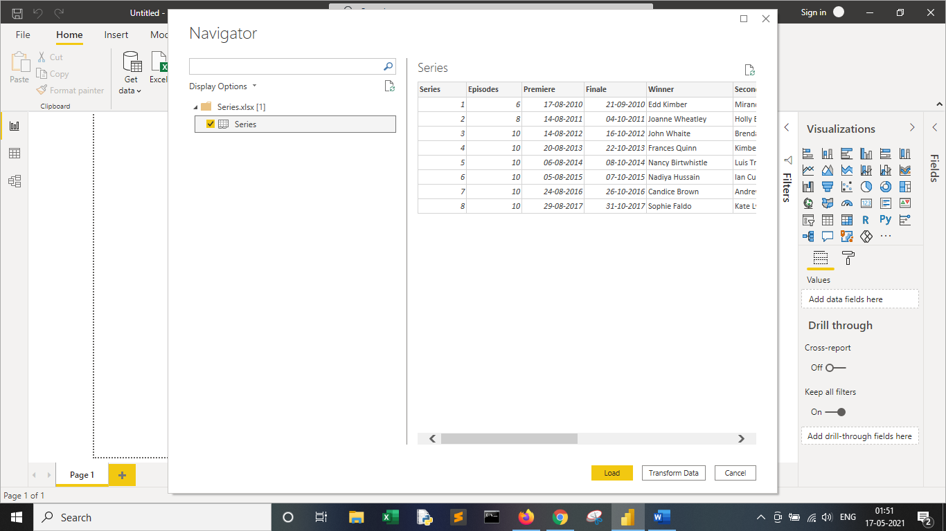

Series Rank = RANKX(ALL(Series),CALCULATE(SUM(Series[Viewers (m)])),,ASC)

**Below is the table along with DAX functions used to calculate the rank of the channel.**

